Ms. Miller’s Counseling Lesson #2, Grade K-5: Calm Down Spot
Lesson based on Positive Discipline in the School and Classroom Manual;
Positive Time Out and Creating the Space, 2018

Welcome! So happy to have you checking out my lessons.
I hope you enjoy them and find them helpful!

You will need a piece of paper, pencil and markers for this activity.

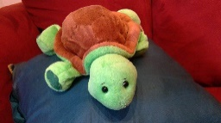 Let’s start by sharing a “Turtle Flo” Story! Did anyone lose their “turtle flo” in the last few days? Did you feel frustrated, angry, worried, stressed? What did you do to get your Turtle Flo back? Write down what you did to get your “Turtle Flo” back or share your idea with someone in your house.

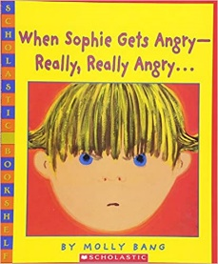 https://www.wevideo.com/view/1624391639

Double click on this video to see Ms. Miller reading this book. This book, and my reading of it, is geared toward younger students. However, the message can support all of us, no matter our age. Special thank you to Scholastic Books for making this video book reading possible during COVID 19!

Now for the lesson….
Think for a minute about a sports team. Sometimes during their game, a coach or player will call a “Time Out”. What is the purpose of a time out?
Answer out loud or tell someone what you think the purpose of a time out is.

(You might have ideas like catch your breath, re-group, or make a new plan.)
We all need a break sometimes. Maybe we have lost our Turtle Flo! Maybe you’re feeling frustrated with some schoolwork. Maybe your little brother or sister keeps asking us to play and you just want some time to yourself. Maybe our mom or dad is telling you that screen time is over and you’re not ready to stop.
It helps to have a place to sort our feelings, calm down, and then make a decision about what to do.
To help us with that, today we are going to make a “Calm Down Spot” that we can have at home! The goal is to create a space where we can calm ourselves, so we can feel better and then do better. It is not a place to be used as a consequence or punishment.

Grab your piece of paper and start designing your calm down space. Think about the following questions:

- Where in my house will it be?
- What can be in my calm down spot that calms me? (books, music, legos, art supplies, stuffies, pillows)
- What will be my theme? Will it be space, nature, Minecraft, ocean, tropical?
- What fun and cool name can I give it? Hawaii, the chill spot, the alone zone, Flo zone?
- What supplies do I need for my spot?
- What kind of help do I need from my parent or older sibling to create this spot?

Keep your calm down spot simple. Use what you have around the house. You might be surprised at how many things you have that can be a part of your spot.

Talk with your parent about some guidelines for your Calm Down Spot. What will be helpful so that this helps you, and works for your family? Post your guidelines near your calm down spot and refer to them often. Change and update them as needed.

Your guidelines might look like….
- This is a spot for calming, not a place to go to avoid schoolwork, meals or chores.
- This is a spot I go to feel better. If I leave my calm down spot and I am not completely calm, I can return to it.
- My family can use the “flipped lid signal” to respectfully remind me that my feelings are getting big and maybe my calm down spot could help.

Extra Activities:
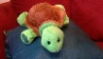Have each member of the family…. even the adults make a calm down spot.
Create some family guidelines around using all the calm down spots.
Send a picture of your calm down spot to Ms. Miller
Write a story about your calm down spot. Use your imagination, make it creative.
Draw a picture of the ultimate calm down spot. Maybe it’s a rocket ship, maybe it’s Minecraft or Roblox structure, maybe it’s a fairy land.

Have fun with this learning! Let me know how it goes! Send me a picture of your calm down spot or any of the extra activities you did.

